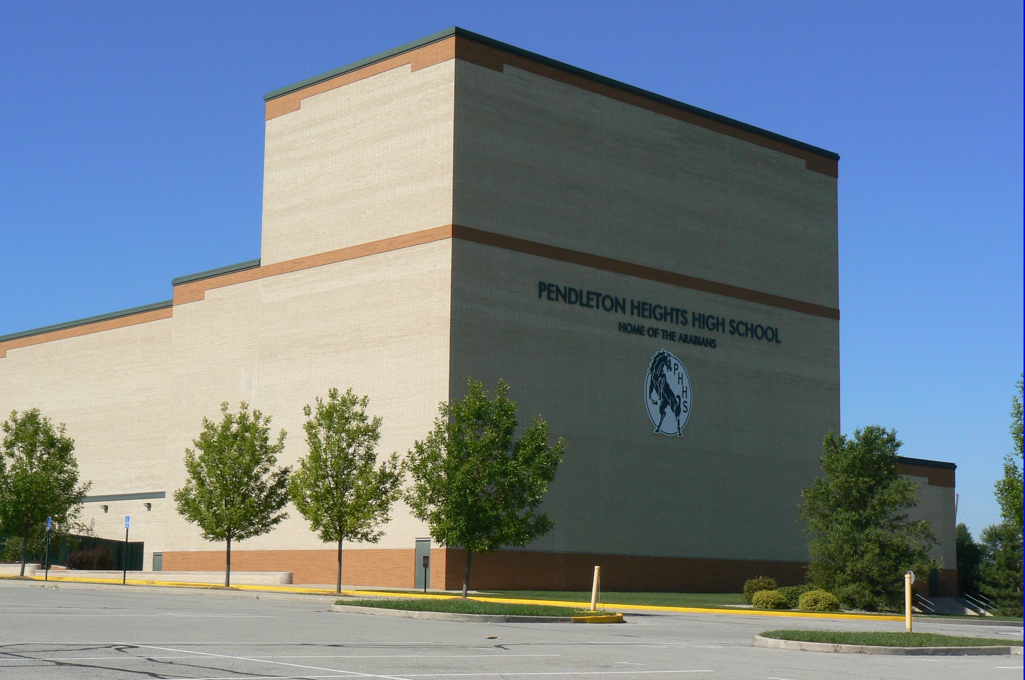  April | 2019

Sunday | Monday | Tuesday | Wednesday | Thursday | Friday | Saturday
 | 1 | 2 | 3 | 4 | 5 | 6
 | 5:30-8:30 Run Show full Tech, Orchestra | 5:30- Dress Rehearsal | 5:30 Dress Rehearsal | 7:30 a.m. – Elementary Visit Field Trip/ NO EVENING REHEARSAL | 7:00 Performance  FOOTLOOSE | 7:00 Performance  FOOTLOOSE
7 | 8 | 9 | 10 | 11 | 12 | 13
1:30 p.m.- Performance Footloose |  | 6:00 p.m.- Preview Concert Band |  | Acting/Musical Theatre Class to Disney | Acting/Musical Theatre Class to Disney | ISSMA- Auditorium  Acting/Musical Theatre Class to Disney
14 | 15 | 16 | 17 | 18 | 19 | 20
Acting/Musical Theatre Class to Disney
21 | 22 | 23 | 24 | 25 | 26 | 27
 |  | 6:00 p.m. –Preview Concert
28 | 29 | 30

