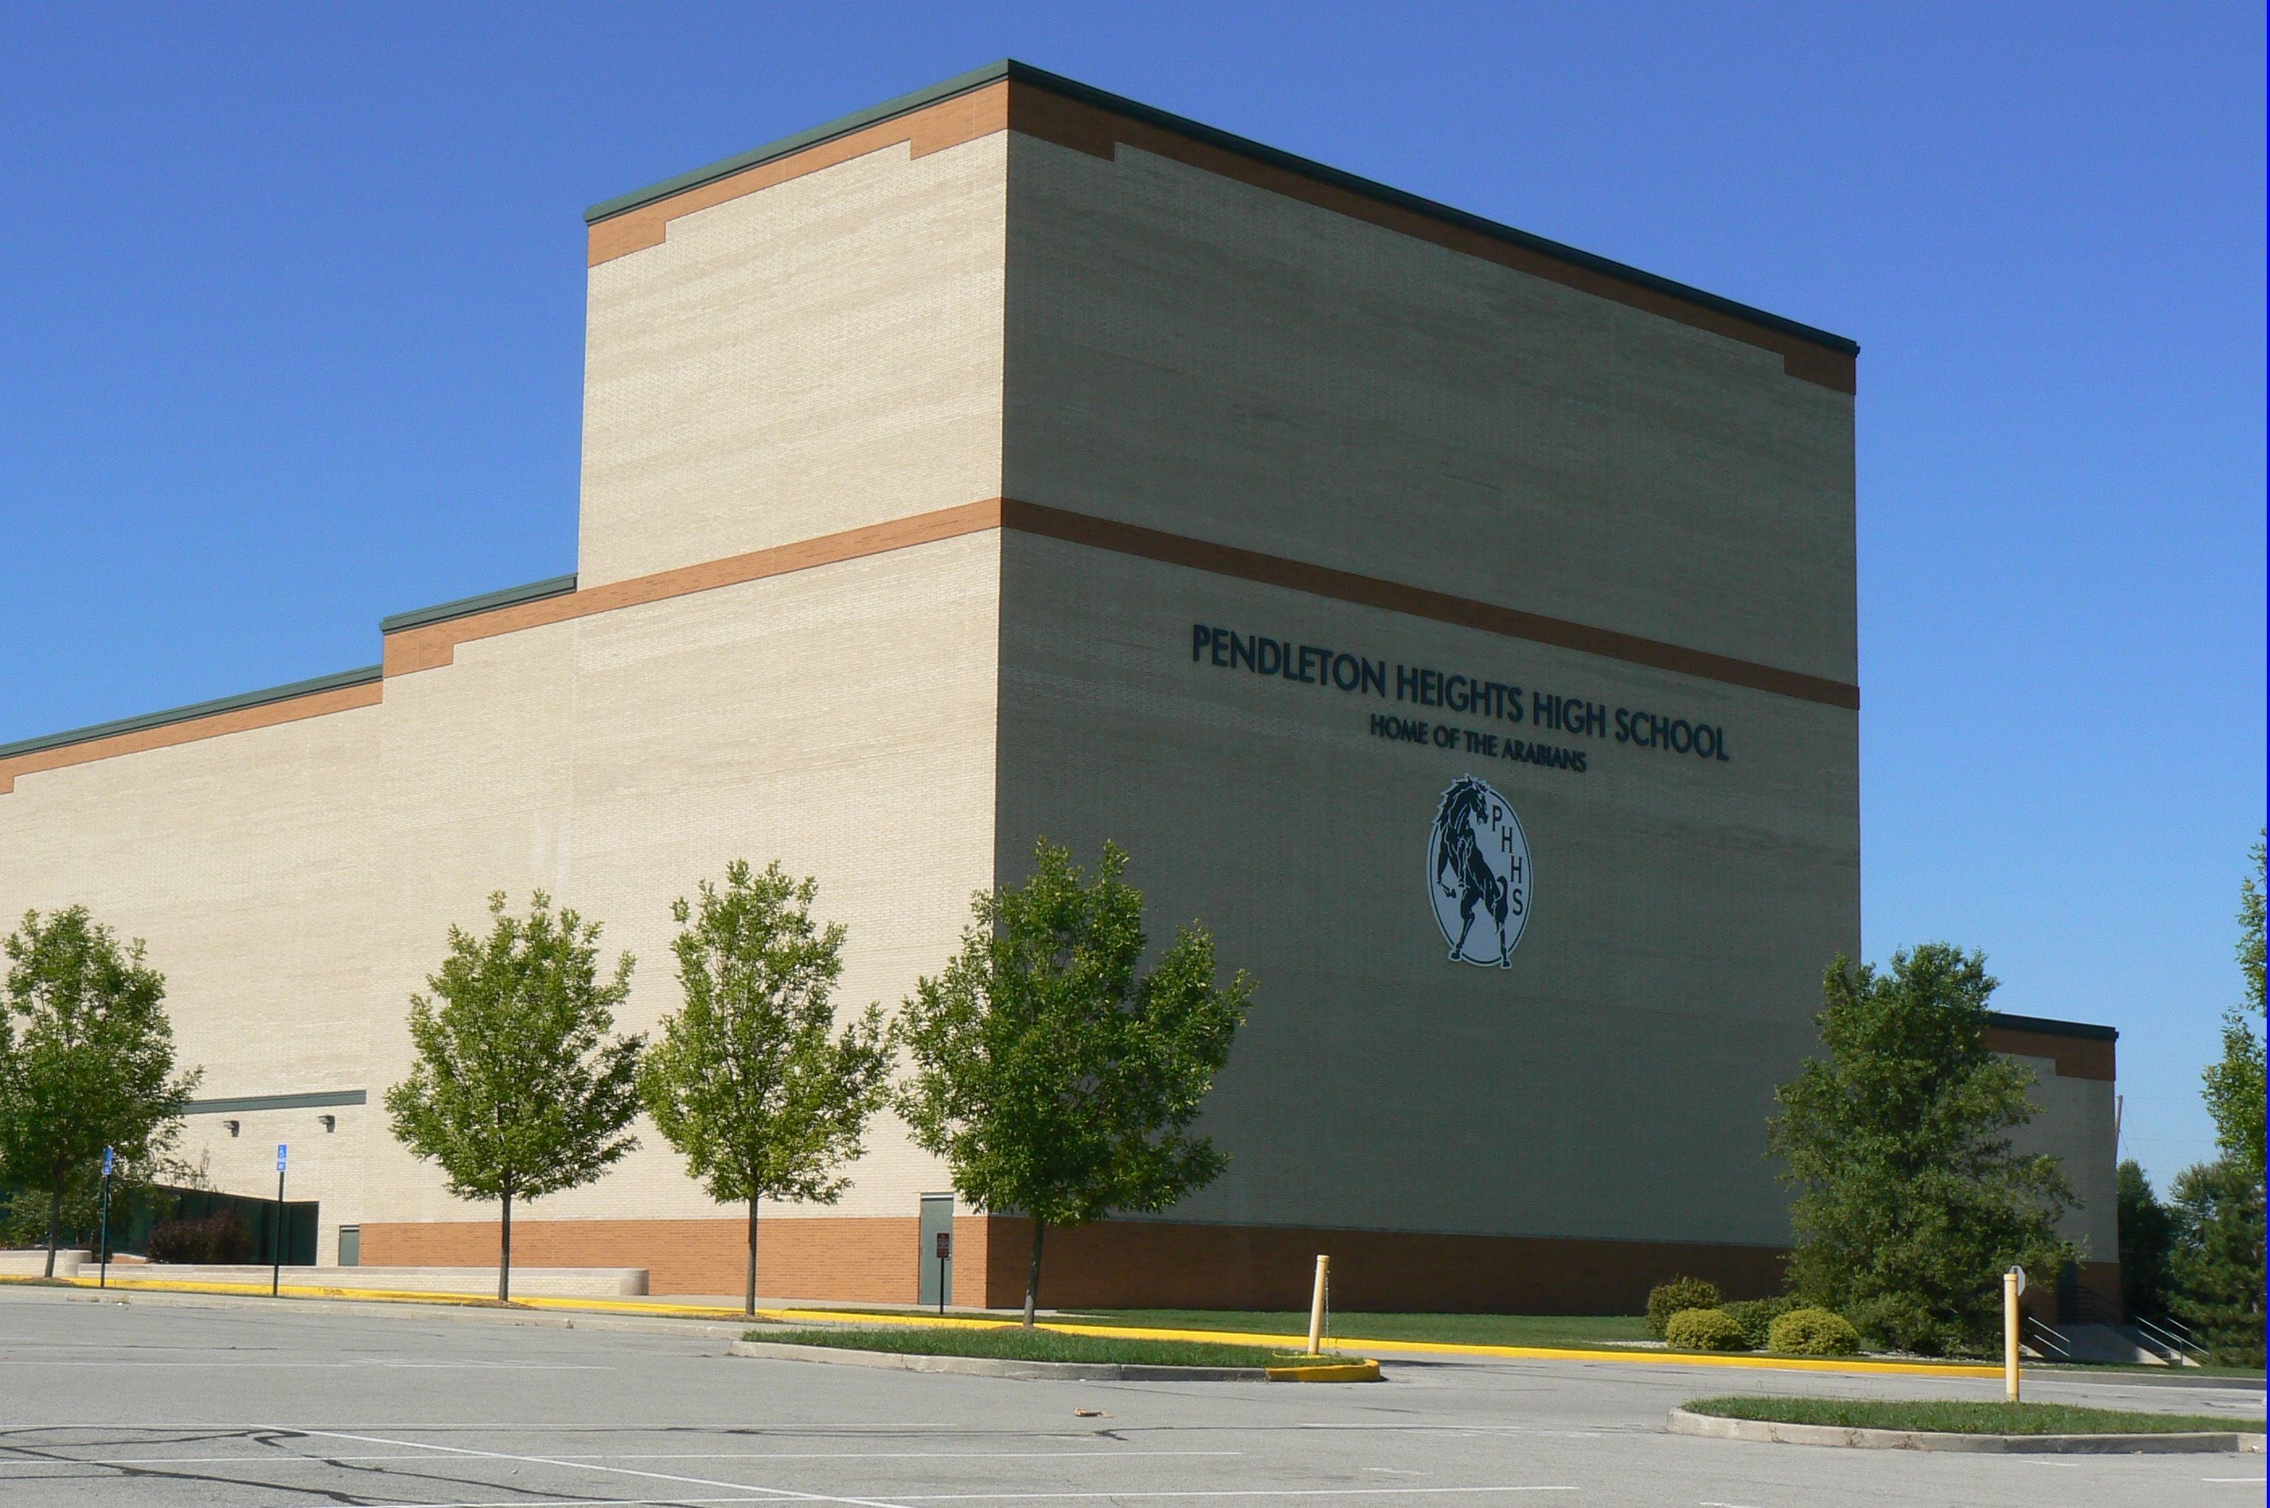  February | 2019

Sunday | Monday | Tuesday | Wednesday | Thursday | Friday | Saturday
 |  |  |  |  | 1 | 2
CHOIR COMPETITION
8:30- Noon Orchestra Rehearsal
3 | 4 | 5 | 6 | 7 | 8 | 9
 | 2:30-5:00 PT /ES (Choir Room)  5:30-7:00 All Cast Vocals  7:00 – 8:30 Act 1, Sc.1 (Church Scene) | 2:30-5:00 PT /ES (Choir Room)  5:30 -7:00 Act 1, Sc. 2 Church Yard  7:00 -8:30 Act 1, Sc 3 (Gas Station) | 2:30-5:00 PT /ES (Choir Room)  5:30- 8:30 Act 1, Sc 4  (High School) | 2:30-5:00 PT /ES (Choir Room)  5:30-8:30 Act 1, Sc.6  (Burger Blast) | MADISON COUNTY JAZZ  FESTIVAL | MADISON COUNTY JAZZ  FESTIVAL
10 | 11 | 12 | 13 | 14 | 15 | 16
 | 2:30-5:00 PT /ES (Choir Room)  5:30-8:30 Act 1, Sc 5, Act 2, Sc. 2 & 6  (Moore Home) | 2:30-5:00 PT /ES (Choir Room)  5:30-7:00 Act 1, Sc 7  (Great Plains)  7:00 8:30 Act 1, Sc.8  (Moore Home) | 2:30-5:00 PT /ES (Choir Room)  5:30 -7:00 Girls Group  7:00 -8:30 Junk Men  (With Jim) | 2:30-5:00 PT /ES (Choir Room) |  | CHOIR COMPETITION  8:30- Noon Orchestra Rehearsal
17 | 18 | 19 | 20 | 21 | 22 | 23
 | 2:30-5:00 PT /ES (Choir Room)  5:30 -7:00 Ren/Ariel Vocals w/Jim if needed  7:00-8:30 Vi/Rev Vocals  if needed | 2:30-5:00 PT /ES (Choir Room)  5:30-8:30 Act 1, Scene 9  (Gym) | 2:30-5:00 PT /ES (Choir Room)  5:30- 8:30 RUN ACT 1 | 2:30-5:00 PT /ES (Choir Room)  5:30-7:00 Act 2, Sc 3 (Junk)  7:00 -8:30 Act 2, Sc 4  (Train Track) |  | CHOIR COMPETITION  8:30- Noon Orchestra Rehearsal  10-4 WORK DAY AUDITORIUM
24 | 25 | 26 | 27 | 28
 | 2:30-5:00 PT /ES (Choir Room)  5:30-8:30 Act 2, Sc1  (BBQ) | 2:30-5:00 PT /ES (Choir Room)  5:30-8:30 Act 2, Scene 5  (Town Hall) | 2:30-5:00 PT /ES (Choir Room)  5:30-8:30 Act 2, Scene 7 (Dance) Teen Group | 2:30-5:00 PT /ES (Choir Room)  5:30- 8:30 Run Act 2 Add Megamix

